## horizontal line



Docklands Bike

10.16.2024

**─**

Your Name

123 Your Street

Your City, ST 12345

# 

**Table Of Content**

**Overview 2**

**Introduction 2**

**ERD 3**

**Figma-Design 4**

**Goals 8**

**Specifications 9**

**Milestones 9**

**Executive Summary 10**

# Overview

The Docklands Bike project aims to develop an efficient and user-friendly web application that enables customers to browse, purchase, and manage orders for high-end bicycles. The application integrates key business operations such as inventory management, customer handling, and payment processing, streamlining the shop’s online sales and providing a smooth customer experience. The platform leverages technologies like HTML, PHP, MySQL, and CSS to deliver a robust solution that addresses the business's and its customers' needs.

# Introduction

The Docklands Bike project was initiated to address the growing need for a robust online platform that could streamline the business operations of the Docklands Bike shop, which specializes in high-end bicycle sales. With the increasing demand for a convenient and efficient online shopping experience, the shop required a web application to manage its inventory, customer data, orders, and payments seamlessly.

The developed system enables customers to browse bicycles from well-known brands such as Trek, Specialized, and Cannondale, place orders, and make payments using multiple payment methods. Additionally, the system simplifies the shop’s inventory management and order tracking, allowing for real-time updates on stock and ensuring that customers receive accurate product availability information.

To build this platform, technologies such as **HTML, CSS, PHP**, and **MySQL** were used. **HTML** and **CSS** were employed for the user interface, ensuring the front-end is visually appealing and user-friendly. **PHP** acts as the back-end server-side language, handling data processing, user requests, and interactions with the database. **MySQL** was used to create the database, allowing the system to efficiently manage multiple tables, including customers, orders, payments, and inventory.

This project has been developed to enhance the Docklands Bike shop’s business processes by delivering a more convenient, reliable, and scalable solution for both customers and the shop’s management team.

# ERD

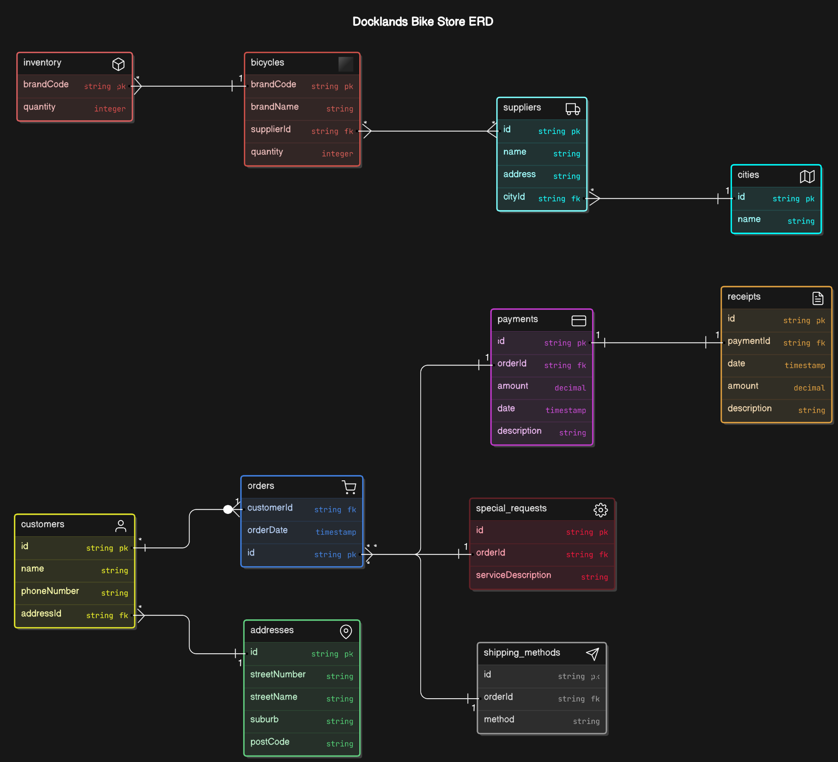

# Figma-Design

# Goals

1. Develop a seamless online experience for customers to browse and purchase bicycles.
2. Enable the shop to manage inventory, orders, and payments efficiently through an integrated system.
3. Create a user-friendly interface that allows customers to add items to their cart without requiring login, thus improving the shopping experience.
4. Incorporate secure payment processing and ensure that customer data is protected.
5. Implement features that allow for special requests, customizable shipping options, and receipt generation.

# Specifications

* **User Registration and Login:** Customers can optionally register for an account, but cart functionality works without login. Sessions are managed through unique identifiers to track guest users.
* **Product Management:** The system handles a wide range of bicycles with different brands, quantities, and images stored in the database. Real-time updates ensure inventory is accurate.
* **Order Processing:** Customers can place orders, make payments using different methods (credit card, PayPal, cash), and receive receipts. Orders are linked to customer details and shipping options.
* **Database Design:** The application features a relational database with multiple tables (e.g., customers, orders, payments) and a carefully constructed ERD to support efficient data retrieval and modification.
* **Front-End Design:** The application interface is designed for ease of use, with clear navigation, a responsive layout, and integration of storyboards for a cohesive user experience.

# Milestones

* **Initial Research and Requirements Gathering**: Define project goals, assess the business needs of Docklands Bike, and identify the functional requirements of the system.
* **Design Phase (Storyboards and ERD)**: Develop visual storyboards for the user interface, create wireframes, and finalize the ERD for database structure.
* **Development Phase**: Implement back-end functionality with PHP and MySQL, set up database tables, and integrate front-end components like cart functionality, product browsing, and user registration.
* **Testing and Debugging**: Thoroughly test each feature to ensure the system works as intended, paying close attention to the payment integration and order confirmation process.
* **Deployment and Presentation**: Finalize the web application, submit all project files (including code scripts), and prepare a presentation that highlights the key outcomes of the project.

# Executive Summary

This report outlines the design and development of an e-commerce bicycle shop management system. It details the system requirements, design process, database architecture, and application functionality. The report is accompanied by a fully functional web application that allows customers to browse, order, and manage bicycles. Storyboards, database ERD, and code are provided to demonstrate the design approach. The application aims to enhance user experience and streamline business operations."